Travel Booking System

Harsh Patel s21901

Prashant Sharma s20985

# Project Description:

In a travel booking system, the process begins with a customer selecting a destination and choosing their travel preferences (such as dates, accommodation type, and transportation options). The customer proceeds to book the travel package and can opt to pay for it in full or in installments. If the installment option is chosen, the booking request is sent to the financial department for further handling. A finance representative prepares an installment plan and shares it with the customer for approval. If the customer does not respond within a specified time or rejects the plan, the booking is canceled. If the response is positive or if the customer chooses to pay in full, they are prompted to select a payment method. The available options can include credit card payment or bank transfer. The system verifies the payment and sends a confirmation email to the customer. If all the travel components (e.g., flights, accommodations) are available, the booking is confirmed, and the customer receives a confirmation email with the itinerary details. However, if any component is not available, the system forwards the request to the respective service provider (e.g., airlines, hotels) and waits for confirmation. Once all the components are confirmed, the system generates the travel package, including tickets and accommodation vouchers, and sends them to the customer. If there are any delays in availability or changes to the itinerary, the customer is notified via email.

# Business Use Case Diagram

The Business Use Case Diagram has actors Customer, Financial Department Employee and Service Provider Employee. Fill preferences business use case is for customer to fill travel package preferences.

See list of payment plans use case appears and includes use case choose a plan. Make payment use case includes the use case of see list of payment methods. Then view tour components use case is to view the tour components of travel package and the include use case is for the customer to download the travelling components.

Financial Department employees have use case to see the customer’s chosen payment plan. Also, he is responsible for creating the payment plan for customers, then it includes the use case to upload the view of the created plan for customers. Use case to see the status of the uploaded payment plan is to keep track of the payment plan if the customer has accepted the plan or rejected it.

The service provider Employee has the use case to see the missing components of the travel package and has the use case to upload the tour components requested.

# Business Use Case Diagram Automated

In this Automated Business Use Case Diagram there is inclusion of use case for customer to use PayPal or Klarna as the payment methods after choosing the payment plan and it makes it way more easier for the customer and the company to settle the payments.

# BPMN

The BPMN diagram here is to show the flow of the process for the travel company and customer to book a travel package. In this BPMN customer set preferences and then it is forwarded to financial department employee to create a payment plan based on chosen plan of customer and then the customer must choose the payment methods and if some components of travel package are missing it is forwarded to service provider employee and then he forwards the missing components and customer receives the final travel package and the BPMN flow ends.

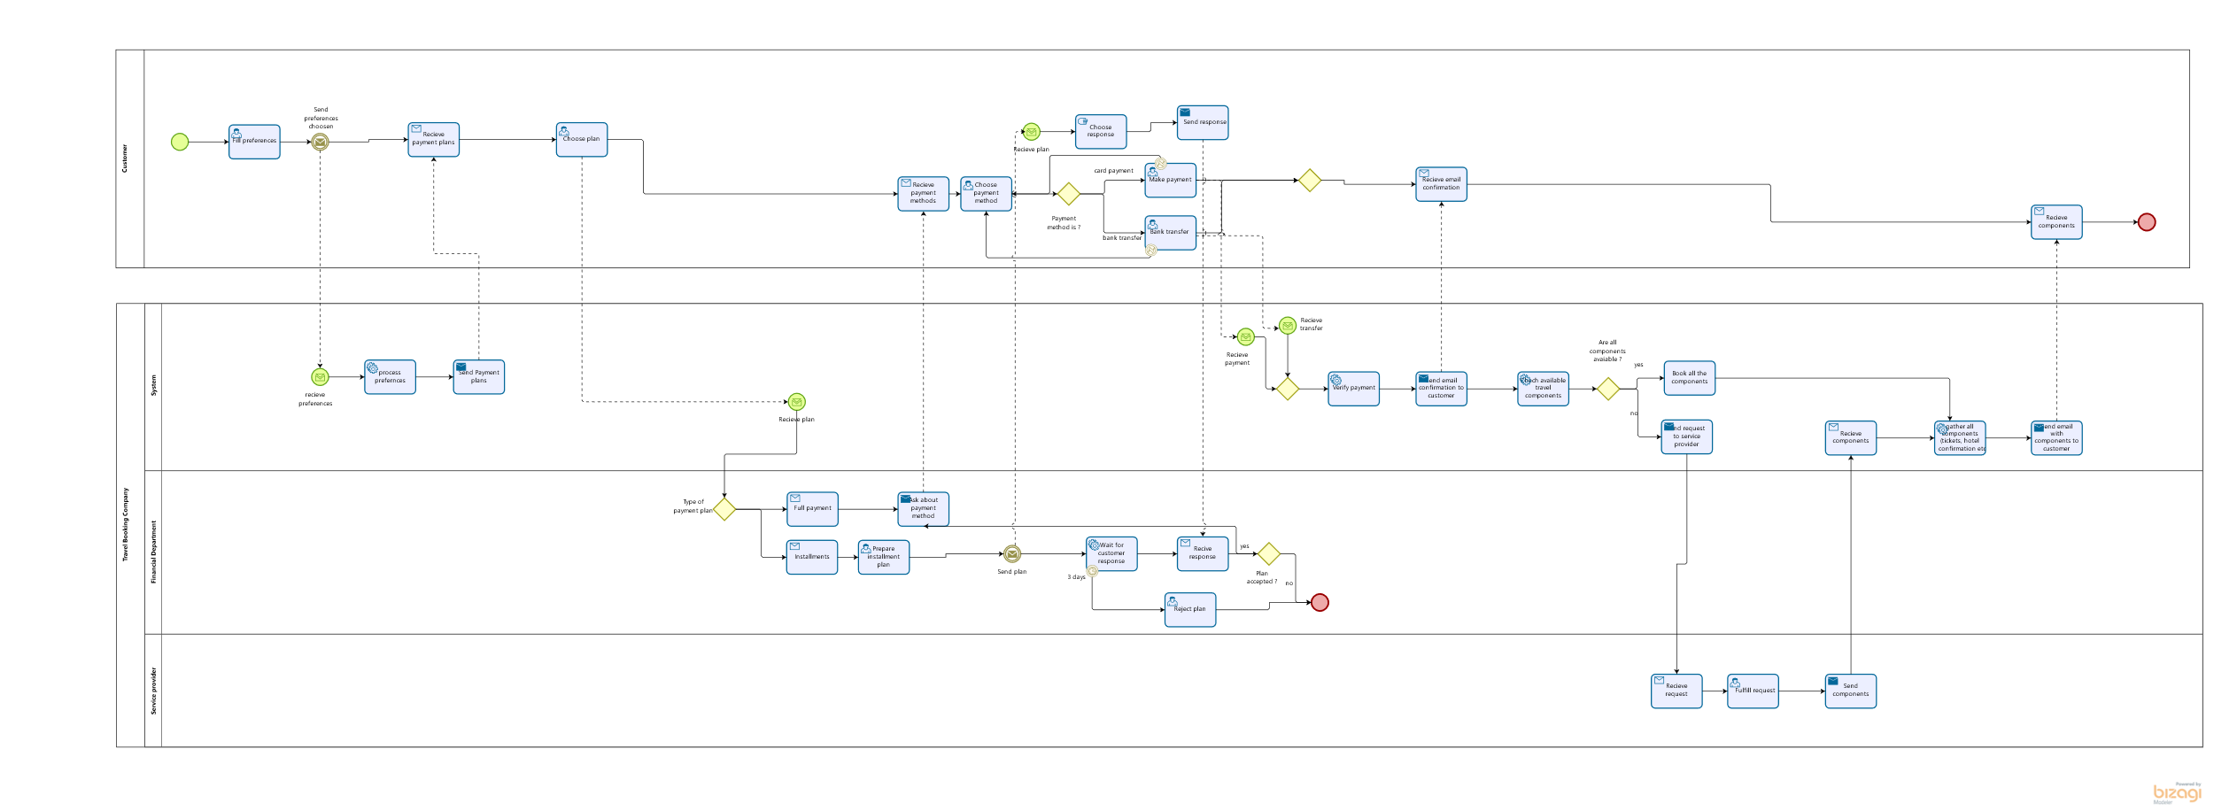

# BPMN Automated

The Automated BPMN has the tool for customers and financial department to communicate and set the payment plan which is easier and faster. Then it has the inclusion for the customer to choose PayPal or Klarna to settle payment and it is way more efficient then the previous process.

# 

# Simulation before Automation

# Simulation after Automation

# Sequence Diagram

The sequence diagram describes the flow of booking a travel package on the website. The alternative loop is described if the customer chooses to pay the full amount or wants to break down the payments in installments. It has one more alternative loop to describe if the company does not have all the tour components and the resource provider fulfills the requested tour components.

# Class Diagram

Class Diagram have person class to store the basis information about person then the class Customer, Finance employee and service provider employee inherits the basic info from person class. Finance employee has attribute salary and bonus, bonus attribute has been set to be optional. Service provider employee also has salary attribute and providerType attribute and the type has fixed values which is shown in the class. There is an many to many association between Customer and Travel package class and it has association with attribute as booking because booking has to be shown for both customer and Travel Package. Booking class has status and it fixed types as shown in the diagram below, it also has an derived attribute /totalPrice which is the calculated total price for the booking. Payment plan attribute has an composition to booking because if the booking is cancelled or deleted the payment plan also gets deleted with booking.

# Prototype of user screens

# Conclusion:

The automated process has improved by great instance, total unit cost has improved slightly in certain areas. In the original process, the System had an total cost 44,416 PLN with utilization rate of 10.66%, But in the automated process its total cost is 25,416 PLN and utilization rate of 14.21% and the unit cost was reduced but the fixed cost was increased still the difference in significantly large. The Financial Department employee also has reduced the total cost to 7,187 PLN and earlier it was 49.375 PLN. However, the utilization rate has increased to 99.48% but the total fixed cost and total unit cost has reduced to 5,000 PLN and 2,187 PLN from 15,000 PLN and 34,375 PLN, which improves the condition of the company. The Resource provider employee has a 0% utilization rate in improved process with cost of 30,000 PLN and earlier it 812,000 PLN so it is the main factor in reducing the overall cost of the company.

By Removing the major cost of Resource provider and also some improvements for financial department and system the company have save a total of 793,187.5 PLN which is now utilized to create more departments in company and use of technology to improve the customer service and process.